Small Autonomous Vehicle

# Small Autonomous Vehicle

#### Attribute

|  |  |
| --- | --- |
| *Element-Typ* | uml:Model |

## 1. Requirements

#### Attribute

|  |  |
| --- | --- |
| *Element-Typ* | Package |

#### Aussagen

|  |  |  |
| --- | --- | --- |
| 1. Requirements | *enthält* | ▣  Original Requirement Specification |

### ▣  Original Requirement Specification

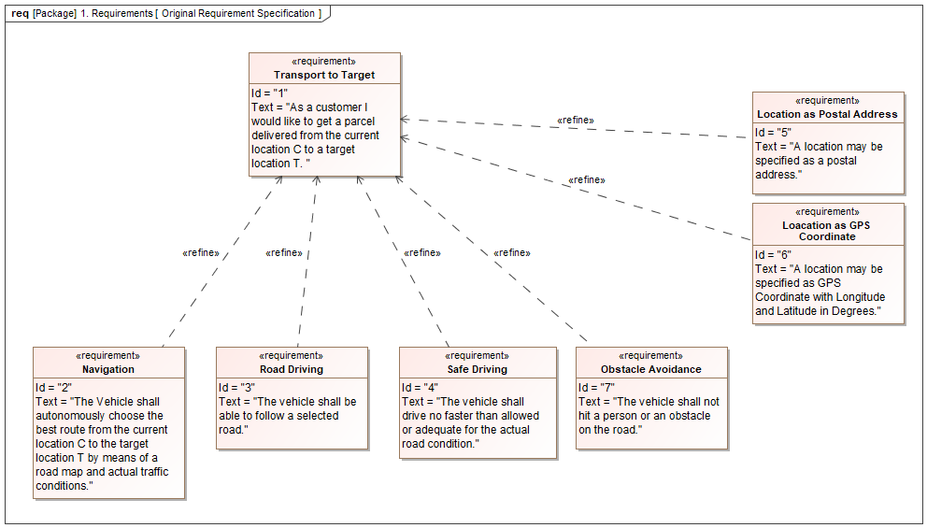

#### Attribute

|  |  |
| --- | --- |
| *Element-Typ* | Diagramm |
| *Notation* | UML Requirement Diagram |

#### Aussagen

|  |  |  |
| --- | --- | --- |
| 1. Requirements | *enthält* | ▣  Original Requirement Specification |
| ▣  Original Requirement Specification | *zeigt* | ↯  Location as Postal Address  ↯  Loacation as GPS Coordinate  ↯  Transport to Target  ↯  Obstacle Avoidance  ↯  Navigation  ↯  Safe Driving  ↯  Road Driving |

### ↯  Navigation

The Vehicle shall autonomously choose the best route from the current location C to the target location T by means of a road map and actual traffic conditions.

#### Attribute

|  |  |
| --- | --- |
| *Element-Typ* | Klasse |

#### Aussagen

|  |  |  |
| --- | --- | --- |
| ↯  Navigation | *verfeinert* | ↯  Transport to Target |
| ☆  Navigate | *erfüllt* | ↯  Navigation |
| ▣  Functional Decomposition  ▣  Original Requirement Specification | *zeigt* | ↯  Navigation |

### ↯  Road Driving

The vehicle shall be able to follow a selected road.

#### Attribute

|  |  |
| --- | --- |
| *Element-Typ* | Klasse |

#### Aussagen

|  |  |  |
| --- | --- | --- |
| ↯  Road Driving | *verfeinert* | ↯  Transport to Target |
| ☆  Follow the Road | *erfüllt* | ↯  Road Driving |
| ▣  Functional Decomposition  ▣  Original Requirement Specification | *zeigt* | ↯  Road Driving |

### ↯  Transport to Target

As a customer I would like to get a parcel delivered from the current location C to a target location T.

#### Attribute

|  |  |
| --- | --- |
| *Element-Typ* | Klasse |

#### Aussagen

|  |  |  |
| --- | --- | --- |
| ↯  Road Driving  ↯  Loacation as GPS Coordinate  ↯  Obstacle Avoidance  ↯  Location as Postal Address  ↯  Safe Driving  ↯  Navigation | *verfeinert* | ↯  Transport to Target |
| ▣  Original Requirement Specification | *zeigt* | ↯  Transport to Target |

### ↯  Location as Postal Address

A location may be specified as a postal address.

#### Attribute

|  |  |
| --- | --- |
| *Element-Typ* | Klasse |

#### Aussagen

|  |  |  |
| --- | --- | --- |
| ↯  Location as Postal Address | *verfeinert* | ↯  Transport to Target |
| ▣  Original Requirement Specification | *zeigt* | ↯  Location as Postal Address |

### ↯  Obstacle Avoidance

The vehicle shall not hit a person or an obstacle on the road.

#### Attribute

|  |  |
| --- | --- |
| *Element-Typ* | Klasse |

#### Aussagen

|  |  |  |
| --- | --- | --- |
| ↯  Obstacle Avoidance | *verfeinert* | ↯  Transport to Target |
| ▣  Original Requirement Specification | *zeigt* | ↯  Obstacle Avoidance |

### ↯  Safe Driving

The vehicle shall drive no faster than allowed or adequate for the actual road condition.

#### Attribute

|  |  |
| --- | --- |
| *Element-Typ* | Klasse |

#### Aussagen

|  |  |  |
| --- | --- | --- |
| ↯  Safe Driving | *verfeinert* | ↯  Transport to Target |
| ☆  Select an adequate Speed | *erfüllt* | ↯  Safe Driving |
| ▣  Functional Decomposition  ▣  Original Requirement Specification | *zeigt* | ↯  Safe Driving |

### ↯  Loacation as GPS Coordinate

A location may be specified as GPS Coordinate with Longitude and Latitude in Degrees.

#### Attribute

|  |  |
| --- | --- |
| *Element-Typ* | Klasse |

#### Aussagen

|  |  |  |
| --- | --- | --- |
| ↯  Loacation as GPS Coordinate | *verfeinert* | ↯  Transport to Target |
| ▣  Original Requirement Specification | *zeigt* | ↯  Loacation as GPS Coordinate |

## 2. Functional Layer

#### Attribute

|  |  |
| --- | --- |
| *Element-Typ* | Package |

#### Aussagen

|  |  |  |
| --- | --- | --- |
| 2. Functional Layer | *enthält* | ☆  Apply Brake  ☆  Follow the Road  ☆  Set Acceleration Right  ☆  Select an adequate Speed  ☆  Set Acceleration Left  ☆  Drive to Target  ☆  Turn Left  ☆  Calculate Accelerations  ☆  Navigate  ☆  Set Radius  ☆  Turn Right  ☆  Set Speed  ☆  Brake in an Emergency  ▣  Functional Decomposition |

### ▣  Functional Decomposition

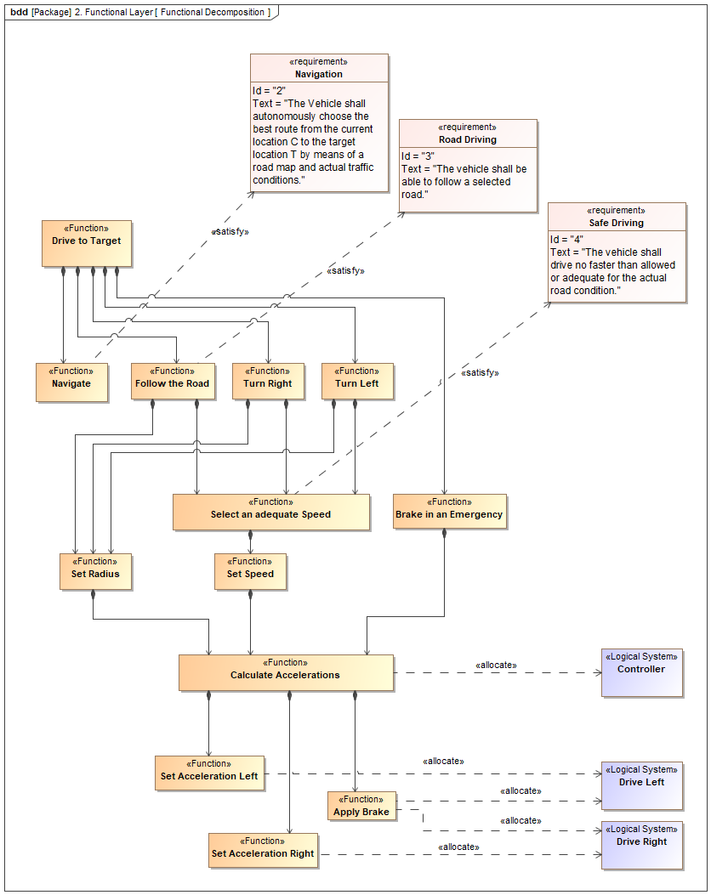

#### Attribute

|  |  |
| --- | --- |
| *Element-Typ* | Diagramm |
| *Notation* | SysML Block Definition Diagram |

#### Aussagen

|  |  |  |
| --- | --- | --- |
| 2. Functional Layer | *enthält* | ▣  Functional Decomposition |
| ▣  Functional Decomposition | *zeigt* | ☆  Apply Brake  ☆  Drive Left  ☆  Select an adequate Speed  ☆  Set Speed  ↯  Road Driving  ☆  Drive Right  ☆  Set Acceleration Left  ☆  Set Radius  ☆  Turn Left  ↯  Navigation  ↯  Safe Driving  ☆  Brake in an Emergency  ☆  Navigate  ☆  Drive to Target  ☆  Turn Right  ☆  Calculate Accelerations  ☆  Set Acceleration Right  ☆  Follow the Road  ☆  Controller |

### ☆  Brake in an Emergency

Take the vehicle to a full stop in the shortest time possible without loosing control over the trajectory.

#### Attribute

|  |  |
| --- | --- |
| *Element-Typ* | RFLP:Function |

#### Aussagen

|  |  |  |
| --- | --- | --- |
| ☆  Drive to Target  2. Functional Layer | *enthält* | ☆  Brake in an Emergency |
| ☆  Brake in an Emergency | *enthält* | ☆  Calculate Accelerations |
| ▣  Functional Decomposition | *zeigt* | ☆  Brake in an Emergency |

### ☆  Set Speed

The (autonomous) driver's speed command (gas pedal position).

#### Attribute

|  |  |
| --- | --- |
| *Element-Typ* | RFLP:Function |

#### Aussagen

|  |  |  |
| --- | --- | --- |
| ☆  Select an adequate Speed  2. Functional Layer | *enthält* | ☆  Set Speed |
| ☆  Set Speed | *enthält* | ☆  Calculate Accelerations |
| ▣  Functional Decomposition | *zeigt* | ☆  Set Speed |

### ☆  Turn Right

Take a right turn at a road intersection. Observe the traffic entering the same lane and avoid a collision, if another vehicle does not observe the priority rules.

#### Attribute

|  |  |
| --- | --- |
| *Element-Typ* | RFLP:Function |

#### Aussagen

|  |  |  |
| --- | --- | --- |
| ☆  Drive to Target  2. Functional Layer | *enthält* | ☆  Turn Right |
| ☆  Turn Right | *enthält* | ☆  Select an adequate Speed  ☆  Set Radius |
| ▣  Functional Decomposition | *zeigt* | ☆  Turn Right |

### ☆  Set Radius

The (autonomous) driver's steering command (steering wheel position).

#### Attribute

|  |  |
| --- | --- |
| *Element-Typ* | RFLP:Function |

#### Aussagen

|  |  |  |
| --- | --- | --- |
| ☆  Turn Right  ☆  Turn Left  ☆  Follow the Road  2. Functional Layer | *enthält* | ☆  Set Radius |
| ☆  Set Radius | *enthält* | ☆  Calculate Accelerations |
| ▣  Functional Decomposition | *zeigt* | ☆  Set Radius |

### ☆  Navigate

Select a path to get from the current position to the target.

#### Attribute

|  |  |
| --- | --- |
| *Element-Typ* | RFLP:Function |

#### Aussagen

|  |  |  |
| --- | --- | --- |
| ☆  Drive to Target  2. Functional Layer | *enthält* | ☆  Navigate |
| ☆  Navigate | *erfüllt* | ↯  Navigation |
| ▣  Functional Decomposition | *zeigt* | ☆  Navigate |

### ☆  Calculate Accelerations

#### Attribute

|  |  |
| --- | --- |
| *Element-Typ* | RFLP:Function |

#### Aussagen

|  |  |  |
| --- | --- | --- |
| ☆  Set Radius  ☆  Set Speed  ☆  Brake in an Emergency  2. Functional Layer | *enthält* | ☆  Calculate Accelerations |
| ☆  Calculate Accelerations | *enthält* | ☆  Set Acceleration Left  ☆  Apply Brake  ☆  Set Acceleration Right |
| ☆  Calculate Accelerations | *zugeordnet zu* | ☆  Controller |
| ▣  Functional Decomposition | *zeigt* | ☆  Calculate Accelerations |

### ☆  Turn Left

Take a left turn in a road intersection. Observe the priority rules and avoid traffic on the two lanes you are crossing.

#### Attribute

|  |  |
| --- | --- |
| *Element-Typ* | RFLP:Function |

#### Aussagen

|  |  |  |
| --- | --- | --- |
| ☆  Drive to Target  2. Functional Layer | *enthält* | ☆  Turn Left |
| ☆  Turn Left | *enthält* | ☆  Select an adequate Speed  ☆  Set Radius |
| ▣  Functional Decomposition | *zeigt* | ☆  Turn Left |

### ☆  Drive to Target

Manoevre the vehicle from the current position to the selected target.

#### Attribute

|  |  |
| --- | --- |
| *Element-Typ* | RFLP:Function |

#### Aussagen

|  |  |  |
| --- | --- | --- |
| 2. Functional Layer | *enthält* | ☆  Drive to Target |
| ☆  Drive to Target | *enthält* | ☆  Follow the Road  ☆  Navigate  ☆  Brake in an Emergency  ☆  Turn Right  ☆  Turn Left |
| ▣  Functional Decomposition | *zeigt* | ☆  Drive to Target |

### ☆  Set Acceleration Left

#### Attribute

|  |  |
| --- | --- |
| *Element-Typ* | RFLP:Function |

#### Aussagen

|  |  |  |
| --- | --- | --- |
| ☆  Calculate Accelerations  2. Functional Layer | *enthält* | ☆  Set Acceleration Left |
| ☆  Set Acceleration Left | *zugeordnet zu* | ☆  Drive Left |
| ▣  Functional Decomposition | *zeigt* | ☆  Set Acceleration Left |

### ☆  Select an adequate Speed

Taking into account road condition and weather, select a safe speed.

#### Attribute

|  |  |
| --- | --- |
| *Element-Typ* | RFLP:Function |

#### Aussagen

|  |  |  |
| --- | --- | --- |
| ☆  Follow the Road  ☆  Turn Left  ☆  Turn Right  2. Functional Layer | *enthält* | ☆  Select an adequate Speed |
| ☆  Select an adequate Speed | *enthält* | ☆  Set Speed |
| ☆  Select an adequate Speed | *erfüllt* | ↯  Safe Driving |
| ▣  Functional Decomposition | *zeigt* | ☆  Select an adequate Speed |

### ☆  Set Acceleration Right

#### Attribute

|  |  |
| --- | --- |
| *Element-Typ* | RFLP:Function |

#### Aussagen

|  |  |  |
| --- | --- | --- |
| ☆  Calculate Accelerations  2. Functional Layer | *enthält* | ☆  Set Acceleration Right |
| ☆  Set Acceleration Right | *zugeordnet zu* | ☆  Drive Right |
| ▣  Functional Decomposition | *zeigt* | ☆  Set Acceleration Right |

### ☆  Follow the Road

Keep the vehicle on the selected road.

#### Attribute

|  |  |
| --- | --- |
| *Element-Typ* | RFLP:Function |

#### Aussagen

|  |  |  |
| --- | --- | --- |
| ☆  Drive to Target  2. Functional Layer | *enthält* | ☆  Follow the Road |
| ☆  Follow the Road | *enthält* | ☆  Select an adequate Speed  ☆  Set Radius |
| ☆  Follow the Road | *erfüllt* | ↯  Road Driving |
| ▣  Functional Decomposition | *zeigt* | ☆  Follow the Road |

### ☆  Apply Brake

#### Attribute

|  |  |
| --- | --- |
| *Element-Typ* | RFLP:Function |

#### Aussagen

|  |  |  |
| --- | --- | --- |
| ☆  Calculate Accelerations  2. Functional Layer | *enthält* | ☆  Apply Brake |
| ☆  Apply Brake | *zugeordnet zu* | ☆  Drive Right  ☆  Drive Left |
| ▣  Functional Decomposition | *zeigt* | ☆  Apply Brake |

## 3. Logical Layer

#### Attribute

|  |  |
| --- | --- |
| *Element-Typ* | Package |

#### Aussagen

|  |  |  |
| --- | --- | --- |
| 3. Logical Layer | *enthält* | ♢  re-navigate!  ♢  new_target!  ♢  navigate!  ♢  emergency_brake!  ♢  halt!  ♢  continue_driving!  ♢  switch_off!  ♢  switch_on!  ♢  turned_left!  ♢  turn_left!  ♢  turned_right!  ♢  turn_right!  ♢  start_driving!  ☆  Collision Alarm Sensor  ☆  Chassis  ☆  Support Rear  ▣  Controller State Machine  □  Controller State Machine  ☆  Controller  ☆  Support Front  ☆  LEGO Mindstorms Vehicle  ☆  Drive Left  ☆  Body  ☆  Track Sensor  ☆  Drive Right  ▣  Logical Decomposition |

### ▣  Logical Decomposition

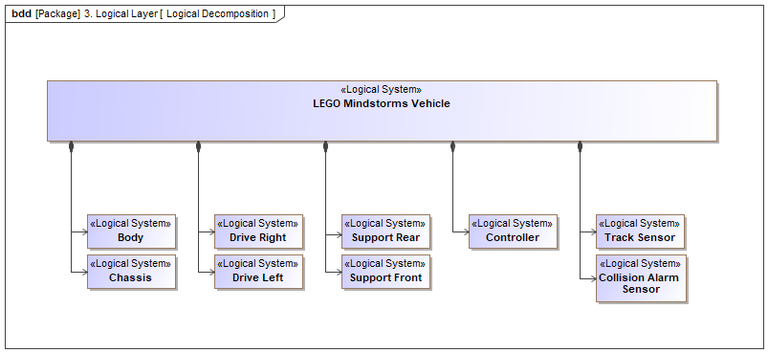

#### Attribute

|  |  |
| --- | --- |
| *Element-Typ* | Diagramm |
| *Notation* | SysML Block Definition Diagram |

#### Aussagen

|  |  |  |
| --- | --- | --- |
| 3. Logical Layer | *enthält* | ▣  Logical Decomposition |
| ▣  Logical Decomposition | *zeigt* | ☆  Drive Left  ☆  LEGO Mindstorms Vehicle  ☆  Support Rear  ☆  Track Sensor  ☆  Chassis  ☆  Body  ☆  Collision Alarm Sensor  ☆  Drive Right  ☆  Support Front  ☆  Controller |

### ☆  Drive Right

The wheel with motor and brake on the right side. The motor can accelerate and decelerate. The motor controller is "4-quadrant" and can supply electrical current for recharging the batteries.

#### Attribute

|  |  |
| --- | --- |
| *Element-Typ* | RFLP:Logical_System |

#### Aussagen

|  |  |  |
| --- | --- | --- |
| ☆  LEGO Mindstorms Vehicle  3. Logical Layer | *enthält* | ☆  Drive Right |
| ☆  Apply Brake  ☆  Set Acceleration Right | *zugeordnet zu* | ☆  Drive Right |
| ▣  Logical Decomposition  ▣  Functional Decomposition | *zeigt* | ☆  Drive Right |

### ☆  Track Sensor

#### Attribute

|  |  |
| --- | --- |
| *Element-Typ* | RFLP:Logical_System |

#### Aussagen

|  |  |  |
| --- | --- | --- |
| ☆  LEGO Mindstorms Vehicle  3. Logical Layer | *enthält* | ☆  Track Sensor |
| ▣  Logical Decomposition | *zeigt* | ☆  Track Sensor |

### ☆  Body

#### Attribute

|  |  |
| --- | --- |
| *Element-Typ* | RFLP:Logical_System |

#### Aussagen

|  |  |  |
| --- | --- | --- |
| ☆  LEGO Mindstorms Vehicle  3. Logical Layer | *enthält* | ☆  Body |
| ▣  Logical Decomposition | *zeigt* | ☆  Body |

### ☆  Drive Left

The wheel with motor and brake on the left side. The motor can accelerate and decelerate. The motor controller is "4-quadrant" and can supply electrical current for recharging the batteries.

#### Attribute

|  |  |
| --- | --- |
| *Element-Typ* | RFLP:Logical_System |

#### Aussagen

|  |  |  |
| --- | --- | --- |
| ☆  LEGO Mindstorms Vehicle  3. Logical Layer | *enthält* | ☆  Drive Left |
| ☆  Set Acceleration Left  ☆  Apply Brake | *zugeordnet zu* | ☆  Drive Left |
| ▣  Logical Decomposition  ▣  Functional Decomposition | *zeigt* | ☆  Drive Left |

### ☆  LEGO Mindstorms Vehicle

#### Attribute

|  |  |
| --- | --- |
| *Element-Typ* | RFLP:Logical_System |

#### Aussagen

|  |  |  |
| --- | --- | --- |
| 3. Logical Layer | *enthält* | ☆  LEGO Mindstorms Vehicle |
| ☆  LEGO Mindstorms Vehicle | *enthält* | ☆  Drive Left  ☆  Support Rear  ☆  Support Front  ☆  Track Sensor  ☆  Body  ☆  Drive Right  ☆  Chassis  ☆  Collision Alarm Sensor  ☆  Controller |
| ▣  Logical Decomposition | *zeigt* | ☆  LEGO Mindstorms Vehicle |

### ☆  Support Front

#### Attribute

|  |  |
| --- | --- |
| *Element-Typ* | RFLP:Logical_System |

#### Aussagen

|  |  |  |
| --- | --- | --- |
| ☆  LEGO Mindstorms Vehicle  3. Logical Layer | *enthält* | ☆  Support Front |
| ▣  Logical Decomposition | *zeigt* | ☆  Support Front |

### ☆  Controller

#### Attribute

|  |  |
| --- | --- |
| *Element-Typ* | RFLP:Logical_System |

#### Aussagen

|  |  |  |
| --- | --- | --- |
| ☆  LEGO Mindstorms Vehicle  3. Logical Layer | *enthält* | ☆  Controller |
| ☆  Controller | *has Behavior* | □  Controller State Machine |
| ☆  Calculate Accelerations | *zugeordnet zu* | ☆  Controller |
| ▣  Logical Decomposition  ▣  Functional Decomposition | *zeigt* | ☆  Controller |

### ▣  Controller State Machine

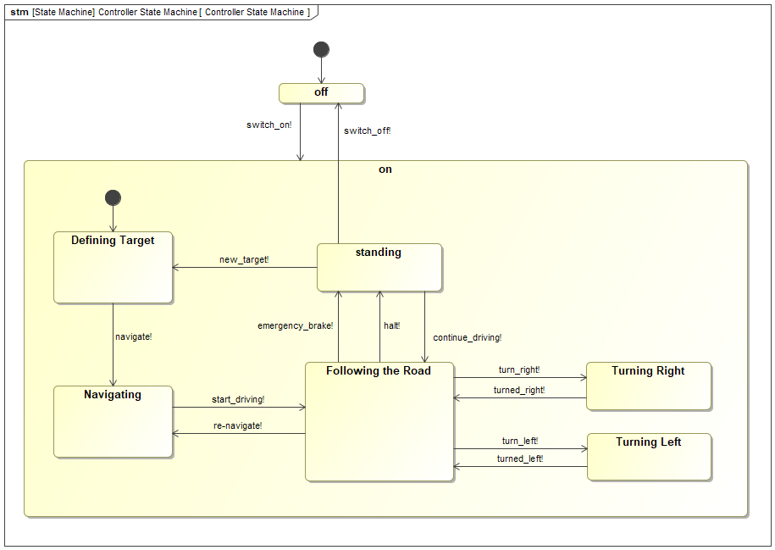

#### Attribute

|  |  |
| --- | --- |
| *Element-Typ* | Diagramm |
| *Notation* | SysML State Machine Diagram |

#### Aussagen

|  |  |  |
| --- | --- | --- |
| 3. Logical Layer | *enthält* | ▣  Controller State Machine |
| □  Controller State Machine | *has Diagram* | ▣  Controller State Machine |
| ▣  Controller State Machine | *zeigt* | ♢  switch_on!  ♢  switch_off!  ♢  new_target!  ♢  continue_driving!  ♢  emergency_brake!  ♢  halt!  ♢  turned_left!  ♢  turn_left!  ♢  turned_right!  ♢  turn_right!  ♢  re-navigate!  ♢  start_driving!  ♢  navigate!  □  unnamed uml:Region  □  Controller State Machine  ○  Turning Left  □  unnamed uml:Region  □  Following the Road→standing  □  standing→off  ○  Defining Target  □  Following the Road→Navigating  □  Navigating→Following the Road  □  Following the Road→standing  □  standing→Following the Road  ○  Following the Road  □  entry→Defining Target  □  standing→Defining Target  ○  on  ○  entry  □  entry→off  □  Following the Road→Turning Left  □  off→on  ○  off  ○  Turning Right  ○  standing  □  Turning Right→Following the Road  □  Following the Road→Turning Right  □  Defining Target→Navigating  ○  entry  □  Turning Left→Following the Road  ○  Navigating |

### ♢  switch_on!

#### Attribute

|  |  |
| --- | --- |
| *Element-Typ* | Signal-Event |

#### Aussagen

|  |  |  |
| --- | --- | --- |
| ♢  switch_on! | *triggers* | □  off→on |
| 3. Logical Layer | *enthält* | ♢  switch_on! |
| ▣  Controller State Machine | *zeigt* | ♢  switch_on! |

### ♢  switch_off!

#### Attribute

|  |  |
| --- | --- |
| *Element-Typ* | Signal-Event |

#### Aussagen

|  |  |  |
| --- | --- | --- |
| ♢  switch_off! | *triggers* | □  standing→off |
| 3. Logical Layer | *enthält* | ♢  switch_off! |
| ▣  Controller State Machine | *zeigt* | ♢  switch_off! |

### ♢  navigate!

#### Attribute

|  |  |
| --- | --- |
| *Element-Typ* | Signal-Event |

#### Aussagen

|  |  |  |
| --- | --- | --- |
| ♢  navigate! | *triggers* | □  Defining Target→Navigating |
| 3. Logical Layer | *enthält* | ♢  navigate! |
| ▣  Controller State Machine | *zeigt* | ♢  navigate! |

### ♢  new_target!

#### Attribute

|  |  |
| --- | --- |
| *Element-Typ* | Signal-Event |

#### Aussagen

|  |  |  |
| --- | --- | --- |
| ♢  new_target! | *triggers* | □  standing→Defining Target |
| 3. Logical Layer | *enthält* | ♢  new_target! |
| ▣  Controller State Machine | *zeigt* | ♢  new_target! |

### ♢  start_driving!

#### Attribute

|  |  |
| --- | --- |
| *Element-Typ* | Signal-Event |

#### Aussagen

|  |  |  |
| --- | --- | --- |
| ♢  start_driving! | *triggers* | □  Navigating→Following the Road |
| 3. Logical Layer | *enthält* | ♢  start_driving! |
| ▣  Controller State Machine | *zeigt* | ♢  start_driving! |

### ♢  re-navigate!

#### Attribute

|  |  |
| --- | --- |
| *Element-Typ* | Call-Event |

#### Aussagen

|  |  |  |
| --- | --- | --- |
| ♢  re-navigate! | *triggers* | □  Following the Road→Navigating |
| 3. Logical Layer | *enthält* | ♢  re-navigate! |
| ▣  Controller State Machine | *zeigt* | ♢  re-navigate! |

### ♢  emergency_brake!

#### Attribute

|  |  |
| --- | --- |
| *Element-Typ* | Signal-Event |

#### Aussagen

|  |  |  |
| --- | --- | --- |
| ♢  emergency_brake! | *triggers* | □  Following the Road→standing |
| 3. Logical Layer | *enthält* | ♢  emergency_brake! |
| ▣  Controller State Machine | *zeigt* | ♢  emergency_brake! |

### ♢  halt!

#### Attribute

|  |  |
| --- | --- |
| *Element-Typ* | Signal-Event |

#### Aussagen

|  |  |  |
| --- | --- | --- |
| ♢  halt! | *triggers* | □  Following the Road→standing |
| 3. Logical Layer | *enthält* | ♢  halt! |
| ▣  Controller State Machine | *zeigt* | ♢  halt! |

### ♢  continue_driving!

#### Attribute

|  |  |
| --- | --- |
| *Element-Typ* | Signal-Event |

#### Aussagen

|  |  |  |
| --- | --- | --- |
| ♢  continue_driving! | *triggers* | □  standing→Following the Road |
| 3. Logical Layer | *enthält* | ♢  continue_driving! |
| ▣  Controller State Machine | *zeigt* | ♢  continue_driving! |

### ♢  turn_right!

#### Attribute

|  |  |
| --- | --- |
| *Element-Typ* | Signal-Event |

#### Aussagen

|  |  |  |
| --- | --- | --- |
| ♢  turn_right! | *triggers* | □  Following the Road→Turning Right |
| 3. Logical Layer | *enthält* | ♢  turn_right! |
| ▣  Controller State Machine | *zeigt* | ♢  turn_right! |

### ♢  turned_right!

#### Attribute

|  |  |
| --- | --- |
| *Element-Typ* | Signal-Event |

#### Aussagen

|  |  |  |
| --- | --- | --- |
| ♢  turned_right! | *triggers* | □  Turning Right→Following the Road |
| 3. Logical Layer | *enthält* | ♢  turned_right! |
| ▣  Controller State Machine | *zeigt* | ♢  turned_right! |

### ♢  turn_left!

#### Attribute

|  |  |
| --- | --- |
| *Element-Typ* | Signal-Event |

#### Aussagen

|  |  |  |
| --- | --- | --- |
| ♢  turn_left! | *triggers* | □  Following the Road→Turning Left |
| 3. Logical Layer | *enthält* | ♢  turn_left! |
| ▣  Controller State Machine | *zeigt* | ♢  turn_left! |

### ♢  turned_left!

#### Attribute

|  |  |
| --- | --- |
| *Element-Typ* | Signal-Event |

#### Aussagen

|  |  |  |
| --- | --- | --- |
| ♢  turned_left! | *triggers* | □  Turning Left→Following the Road |
| 3. Logical Layer | *enthält* | ♢  turned_left! |
| ▣  Controller State Machine | *zeigt* | ♢  turned_left! |

### ☆  Support Rear

#### Attribute

|  |  |
| --- | --- |
| *Element-Typ* | RFLP:Logical_System |

#### Aussagen

|  |  |  |
| --- | --- | --- |
| ☆  LEGO Mindstorms Vehicle  3. Logical Layer | *enthält* | ☆  Support Rear |
| ▣  Logical Decomposition | *zeigt* | ☆  Support Rear |

### ☆  Chassis

#### Attribute

|  |  |
| --- | --- |
| *Element-Typ* | RFLP:Logical_System |

#### Aussagen

|  |  |  |
| --- | --- | --- |
| ☆  LEGO Mindstorms Vehicle  3. Logical Layer | *enthält* | ☆  Chassis |
| ▣  Logical Decomposition | *zeigt* | ☆  Chassis |

### ☆  Collision Alarm Sensor

#### Attribute

|  |  |
| --- | --- |
| *Element-Typ* | RFLP:Logical_System |

#### Aussagen

|  |  |  |
| --- | --- | --- |
| ☆  LEGO Mindstorms Vehicle  3. Logical Layer | *enthält* | ☆  Collision Alarm Sensor |
| ▣  Logical Decomposition | *zeigt* | ☆  Collision Alarm Sensor |

# Model Elements (Glossary)

#### Attribute

|  |  |
| --- | --- |
| *Element-Typ* | Model Elements (Glossary) |

### ☆  Apply Brake

#### Attribute

|  |  |
| --- | --- |
| *Element-Typ* | RFLP:Function |

#### Aussagen

|  |  |  |
| --- | --- | --- |
| ☆  Calculate Accelerations  2. Functional Layer | *enthält* | ☆  Apply Brake |
| ☆  Apply Brake | *zugeordnet zu* | ☆  Drive Right  ☆  Drive Left |
| ▣  Functional Decomposition | *zeigt* | ☆  Apply Brake |

### ☆  Body

#### Attribute

|  |  |
| --- | --- |
| *Element-Typ* | RFLP:Logical_System |

#### Aussagen

|  |  |  |
| --- | --- | --- |
| ☆  LEGO Mindstorms Vehicle  3. Logical Layer | *enthält* | ☆  Body |
| ▣  Logical Decomposition | *zeigt* | ☆  Body |

### ☆  Brake in an Emergency

Take the vehicle to a full stop in the shortest time possible without loosing control over the trajectory.

#### Attribute

|  |  |
| --- | --- |
| *Element-Typ* | RFLP:Function |

#### Aussagen

|  |  |  |
| --- | --- | --- |
| ☆  Drive to Target  2. Functional Layer | *enthält* | ☆  Brake in an Emergency |
| ☆  Brake in an Emergency | *enthält* | ☆  Calculate Accelerations |
| ▣  Functional Decomposition | *zeigt* | ☆  Brake in an Emergency |

### ☆  Calculate Accelerations

#### Attribute

|  |  |
| --- | --- |
| *Element-Typ* | RFLP:Function |

#### Aussagen

|  |  |  |
| --- | --- | --- |
| ☆  Set Radius  ☆  Set Speed  ☆  Brake in an Emergency  2. Functional Layer | *enthält* | ☆  Calculate Accelerations |
| ☆  Calculate Accelerations | *enthält* | ☆  Set Acceleration Left  ☆  Apply Brake  ☆  Set Acceleration Right |
| ☆  Calculate Accelerations | *zugeordnet zu* | ☆  Controller |
| ▣  Functional Decomposition | *zeigt* | ☆  Calculate Accelerations |

### ☆  Chassis

#### Attribute

|  |  |
| --- | --- |
| *Element-Typ* | RFLP:Logical_System |

#### Aussagen

|  |  |  |
| --- | --- | --- |
| ☆  LEGO Mindstorms Vehicle  3. Logical Layer | *enthält* | ☆  Chassis |
| ▣  Logical Decomposition | *zeigt* | ☆  Chassis |

### ☆  Collision Alarm Sensor

#### Attribute

|  |  |
| --- | --- |
| *Element-Typ* | RFLP:Logical_System |

#### Aussagen

|  |  |  |
| --- | --- | --- |
| ☆  LEGO Mindstorms Vehicle  3. Logical Layer | *enthält* | ☆  Collision Alarm Sensor |
| ▣  Logical Decomposition | *zeigt* | ☆  Collision Alarm Sensor |

### ♢  continue_driving!

#### Attribute

|  |  |
| --- | --- |
| *Element-Typ* | Signal-Event |

#### Aussagen

|  |  |  |
| --- | --- | --- |
| ♢  continue_driving! | *triggers* | □  standing→Following the Road |
| 3. Logical Layer | *enthält* | ♢  continue_driving! |
| ▣  Controller State Machine | *zeigt* | ♢  continue_driving! |

### ☆  Controller

#### Attribute

|  |  |
| --- | --- |
| *Element-Typ* | RFLP:Logical_System |

#### Aussagen

|  |  |  |
| --- | --- | --- |
| ☆  LEGO Mindstorms Vehicle  3. Logical Layer | *enthält* | ☆  Controller |
| ☆  Controller | *has Behavior* | □  Controller State Machine |
| ☆  Calculate Accelerations | *zugeordnet zu* | ☆  Controller |
| ▣  Logical Decomposition  ▣  Functional Decomposition | *zeigt* | ☆  Controller |

### □  Controller State Machine

#### Attribute

|  |  |
| --- | --- |
| *Element-Typ* | UML State Machine |

#### Aussagen

|  |  |  |
| --- | --- | --- |
| ☆  Controller | *has Behavior* | □  Controller State Machine |
| 3. Logical Layer | *enthält* | □  Controller State Machine |
| □  Controller State Machine | *enthält* | □  unnamed uml:Region |
| □  Controller State Machine | *has Diagram* | ▣  Controller State Machine |
| ▣  Controller State Machine | *zeigt* | □  Controller State Machine |

### ○  Defining Target

#### Attribute

|  |  |
| --- | --- |
| *Element-Typ* | UML State |

#### Aussagen

|  |  |  |
| --- | --- | --- |
| □  unnamed uml:Region | *enthält* | ○  Defining Target |
| □  standing→Defining Target  □  entry→Defining Target | *ends at* | ○  Defining Target |
| □  Defining Target→Navigating | *starts from* | ○  Defining Target |
| ▣  Controller State Machine | *zeigt* | ○  Defining Target |

### □  Defining Target→Navigating

#### Attribute

|  |  |
| --- | --- |
| *Element-Typ* | UML Transition |

#### Aussagen

|  |  |  |
| --- | --- | --- |
| □  Defining Target→Navigating | *starts from* | ○  Defining Target |
| □  Defining Target→Navigating | *ends at* | ○  Navigating |
| ♢  navigate! | *triggers* | □  Defining Target→Navigating |
| ▣  Controller State Machine | *zeigt* | □  Defining Target→Navigating |

### ☆  Drive Left

The wheel with motor and brake on the left side. The motor can accelerate and decelerate. The motor controller is "4-quadrant" and can supply electrical current for recharging the batteries.

#### Attribute

|  |  |
| --- | --- |
| *Element-Typ* | RFLP:Logical_System |

#### Aussagen

|  |  |  |
| --- | --- | --- |
| ☆  LEGO Mindstorms Vehicle  3. Logical Layer | *enthält* | ☆  Drive Left |
| ☆  Set Acceleration Left  ☆  Apply Brake | *zugeordnet zu* | ☆  Drive Left |
| ▣  Logical Decomposition  ▣  Functional Decomposition | *zeigt* | ☆  Drive Left |

### ☆  Drive Right

The wheel with motor and brake on the right side. The motor can accelerate and decelerate. The motor controller is "4-quadrant" and can supply electrical current for recharging the batteries.

#### Attribute

|  |  |
| --- | --- |
| *Element-Typ* | RFLP:Logical_System |

#### Aussagen

|  |  |  |
| --- | --- | --- |
| ☆  LEGO Mindstorms Vehicle  3. Logical Layer | *enthält* | ☆  Drive Right |
| ☆  Apply Brake  ☆  Set Acceleration Right | *zugeordnet zu* | ☆  Drive Right |
| ▣  Logical Decomposition  ▣  Functional Decomposition | *zeigt* | ☆  Drive Right |

### ☆  Drive to Target

Manoevre the vehicle from the current position to the selected target.

#### Attribute

|  |  |
| --- | --- |
| *Element-Typ* | RFLP:Function |

#### Aussagen

|  |  |  |
| --- | --- | --- |
| 2. Functional Layer | *enthält* | ☆  Drive to Target |
| ☆  Drive to Target | *enthält* | ☆  Follow the Road  ☆  Navigate  ☆  Brake in an Emergency  ☆  Turn Right  ☆  Turn Left |
| ▣  Functional Decomposition | *zeigt* | ☆  Drive to Target |

### ♢  emergency_brake!

#### Attribute

|  |  |
| --- | --- |
| *Element-Typ* | Signal-Event |

#### Aussagen

|  |  |  |
| --- | --- | --- |
| ♢  emergency_brake! | *triggers* | □  Following the Road→standing |
| 3. Logical Layer | *enthält* | ♢  emergency_brake! |
| ▣  Controller State Machine | *zeigt* | ♢  emergency_brake! |

### ○  entry

#### Attribute

|  |  |
| --- | --- |
| *Element-Typ* | uml:Pseudostate |

#### Aussagen

|  |  |  |
| --- | --- | --- |
| □  unnamed uml:Region | *enthält* | ○  entry |
| □  entry→off | *starts from* | ○  entry |
| ▣  Controller State Machine | *zeigt* | ○  entry |

### ○  entry

#### Attribute

|  |  |
| --- | --- |
| *Element-Typ* | uml:Pseudostate |

#### Aussagen

|  |  |  |
| --- | --- | --- |
| □  unnamed uml:Region | *enthält* | ○  entry |
| □  entry→Defining Target | *starts from* | ○  entry |
| ▣  Controller State Machine | *zeigt* | ○  entry |

### □  entry→Defining Target

#### Attribute

|  |  |
| --- | --- |
| *Element-Typ* | UML Transition |

#### Aussagen

|  |  |  |
| --- | --- | --- |
| □  entry→Defining Target | *starts from* | ○  entry |
| □  entry→Defining Target | *ends at* | ○  Defining Target |
| ▣  Controller State Machine | *zeigt* | □  entry→Defining Target |

### □  entry→off

#### Attribute

|  |  |
| --- | --- |
| *Element-Typ* | UML Transition |

#### Aussagen

|  |  |  |
| --- | --- | --- |
| □  entry→off | *starts from* | ○  entry |
| □  entry→off | *ends at* | ○  off |
| ▣  Controller State Machine | *zeigt* | □  entry→off |

### ☆  Follow the Road

Keep the vehicle on the selected road.

#### Attribute

|  |  |
| --- | --- |
| *Element-Typ* | RFLP:Function |

#### Aussagen

|  |  |  |
| --- | --- | --- |
| ☆  Drive to Target  2. Functional Layer | *enthält* | ☆  Follow the Road |
| ☆  Follow the Road | *enthält* | ☆  Select an adequate Speed  ☆  Set Radius |
| ☆  Follow the Road | *erfüllt* | ↯  Road Driving |
| ▣  Functional Decomposition | *zeigt* | ☆  Follow the Road |

### ○  Following the Road

#### Attribute

|  |  |
| --- | --- |
| *Element-Typ* | UML State |

#### Aussagen

|  |  |  |
| --- | --- | --- |
| □  unnamed uml:Region | *enthält* | ○  Following the Road |
| □  standing→Following the Road  □  Turning Left→Following the Road  □  Turning Right→Following the Road  □  Navigating→Following the Road | *ends at* | ○  Following the Road |
| □  Following the Road→standing  □  Following the Road→standing  □  Following the Road→Turning Left  □  Following the Road→Turning Right  □  Following the Road→Navigating | *starts from* | ○  Following the Road |
| ▣  Controller State Machine | *zeigt* | ○  Following the Road |

### □  Following the Road→Navigating

#### Attribute

|  |  |
| --- | --- |
| *Element-Typ* | UML Transition |

#### Aussagen

|  |  |  |
| --- | --- | --- |
| □  Following the Road→Navigating | *starts from* | ○  Following the Road |
| □  Following the Road→Navigating | *ends at* | ○  Navigating |
| ♢  re-navigate! | *triggers* | □  Following the Road→Navigating |
| ▣  Controller State Machine | *zeigt* | □  Following the Road→Navigating |

### □  Following the Road→standing

#### Attribute

|  |  |
| --- | --- |
| *Element-Typ* | UML Transition |

#### Aussagen

|  |  |  |
| --- | --- | --- |
| □  Following the Road→standing | *starts from* | ○  Following the Road |
| □  Following the Road→standing | *ends at* | ○  standing |
| ♢  halt! | *triggers* | □  Following the Road→standing |
| ▣  Controller State Machine | *zeigt* | □  Following the Road→standing |

### □  Following the Road→standing

#### Attribute

|  |  |
| --- | --- |
| *Element-Typ* | UML Transition |

#### Aussagen

|  |  |  |
| --- | --- | --- |
| □  Following the Road→standing | *starts from* | ○  Following the Road |
| □  Following the Road→standing | *ends at* | ○  standing |
| ♢  emergency_brake! | *triggers* | □  Following the Road→standing |
| ▣  Controller State Machine | *zeigt* | □  Following the Road→standing |

### □  Following the Road→Turning Left

#### Attribute

|  |  |
| --- | --- |
| *Element-Typ* | UML Transition |

#### Aussagen

|  |  |  |
| --- | --- | --- |
| □  Following the Road→Turning Left | *starts from* | ○  Following the Road |
| □  Following the Road→Turning Left | *ends at* | ○  Turning Left |
| ♢  turn_left! | *triggers* | □  Following the Road→Turning Left |
| ▣  Controller State Machine | *zeigt* | □  Following the Road→Turning Left |

### □  Following the Road→Turning Right

#### Attribute

|  |  |
| --- | --- |
| *Element-Typ* | UML Transition |

#### Aussagen

|  |  |  |
| --- | --- | --- |
| □  Following the Road→Turning Right | *starts from* | ○  Following the Road |
| □  Following the Road→Turning Right | *ends at* | ○  Turning Right |
| ♢  turn_right! | *triggers* | □  Following the Road→Turning Right |
| ▣  Controller State Machine | *zeigt* | □  Following the Road→Turning Right |

### ♢  halt!

#### Attribute

|  |  |
| --- | --- |
| *Element-Typ* | Signal-Event |

#### Aussagen

|  |  |  |
| --- | --- | --- |
| ♢  halt! | *triggers* | □  Following the Road→standing |
| 3. Logical Layer | *enthält* | ♢  halt! |
| ▣  Controller State Machine | *zeigt* | ♢  halt! |

### ☆  LEGO Mindstorms Vehicle

#### Attribute

|  |  |
| --- | --- |
| *Element-Typ* | RFLP:Logical_System |

#### Aussagen

|  |  |  |
| --- | --- | --- |
| 3. Logical Layer | *enthält* | ☆  LEGO Mindstorms Vehicle |
| ☆  LEGO Mindstorms Vehicle | *enthält* | ☆  Drive Left  ☆  Support Rear  ☆  Support Front  ☆  Track Sensor  ☆  Body  ☆  Drive Right  ☆  Chassis  ☆  Collision Alarm Sensor  ☆  Controller |
| ▣  Logical Decomposition | *zeigt* | ☆  LEGO Mindstorms Vehicle |

### ↯  Loacation as GPS Coordinate

A location may be specified as GPS Coordinate with Longitude and Latitude in Degrees.

#### Attribute

|  |  |
| --- | --- |
| *Element-Typ* | Klasse |

#### Aussagen

|  |  |  |
| --- | --- | --- |
| ↯  Loacation as GPS Coordinate | *verfeinert* | ↯  Transport to Target |
| ▣  Original Requirement Specification | *zeigt* | ↯  Loacation as GPS Coordinate |

### ↯  Location as Postal Address

A location may be specified as a postal address.

#### Attribute

|  |  |
| --- | --- |
| *Element-Typ* | Klasse |

#### Aussagen

|  |  |  |
| --- | --- | --- |
| ↯  Location as Postal Address | *verfeinert* | ↯  Transport to Target |
| ▣  Original Requirement Specification | *zeigt* | ↯  Location as Postal Address |

### ☆  Navigate

Select a path to get from the current position to the target.

#### Attribute

|  |  |
| --- | --- |
| *Element-Typ* | RFLP:Function |

#### Aussagen

|  |  |  |
| --- | --- | --- |
| ☆  Drive to Target  2. Functional Layer | *enthält* | ☆  Navigate |
| ☆  Navigate | *erfüllt* | ↯  Navigation |
| ▣  Functional Decomposition | *zeigt* | ☆  Navigate |

### ♢  navigate!

#### Attribute

|  |  |
| --- | --- |
| *Element-Typ* | Signal-Event |

#### Aussagen

|  |  |  |
| --- | --- | --- |
| ♢  navigate! | *triggers* | □  Defining Target→Navigating |
| 3. Logical Layer | *enthält* | ♢  navigate! |
| ▣  Controller State Machine | *zeigt* | ♢  navigate! |

### ○  Navigating

#### Attribute

|  |  |
| --- | --- |
| *Element-Typ* | UML State |

#### Aussagen

|  |  |  |
| --- | --- | --- |
| □  unnamed uml:Region | *enthält* | ○  Navigating |
| □  Following the Road→Navigating  □  Defining Target→Navigating | *ends at* | ○  Navigating |
| □  Navigating→Following the Road | *starts from* | ○  Navigating |
| ▣  Controller State Machine | *zeigt* | ○  Navigating |

### □  Navigating→Following the Road

#### Attribute

|  |  |
| --- | --- |
| *Element-Typ* | UML Transition |

#### Aussagen

|  |  |  |
| --- | --- | --- |
| □  Navigating→Following the Road | *starts from* | ○  Navigating |
| □  Navigating→Following the Road | *ends at* | ○  Following the Road |
| ♢  start_driving! | *triggers* | □  Navigating→Following the Road |
| ▣  Controller State Machine | *zeigt* | □  Navigating→Following the Road |

### ↯  Navigation

The Vehicle shall autonomously choose the best route from the current location C to the target location T by means of a road map and actual traffic conditions.

#### Attribute

|  |  |
| --- | --- |
| *Element-Typ* | Klasse |

#### Aussagen

|  |  |  |
| --- | --- | --- |
| ↯  Navigation | *verfeinert* | ↯  Transport to Target |
| ☆  Navigate | *erfüllt* | ↯  Navigation |
| ▣  Functional Decomposition  ▣  Original Requirement Specification | *zeigt* | ↯  Navigation |

### ♢  new_target!

#### Attribute

|  |  |
| --- | --- |
| *Element-Typ* | Signal-Event |

#### Aussagen

|  |  |  |
| --- | --- | --- |
| ♢  new_target! | *triggers* | □  standing→Defining Target |
| 3. Logical Layer | *enthält* | ♢  new_target! |
| ▣  Controller State Machine | *zeigt* | ♢  new_target! |

### ↯  Obstacle Avoidance

The vehicle shall not hit a person or an obstacle on the road.

#### Attribute

|  |  |
| --- | --- |
| *Element-Typ* | Klasse |

#### Aussagen

|  |  |  |
| --- | --- | --- |
| ↯  Obstacle Avoidance | *verfeinert* | ↯  Transport to Target |
| ▣  Original Requirement Specification | *zeigt* | ↯  Obstacle Avoidance |

### ○  off

#### Attribute

|  |  |
| --- | --- |
| *Element-Typ* | UML State |

#### Aussagen

|  |  |  |
| --- | --- | --- |
| □  unnamed uml:Region | *enthält* | ○  off |
| □  entry→off  □  standing→off | *ends at* | ○  off |
| □  off→on | *starts from* | ○  off |
| ▣  Controller State Machine | *zeigt* | ○  off |

### □  off→on

#### Attribute

|  |  |
| --- | --- |
| *Element-Typ* | UML Transition |

#### Aussagen

|  |  |  |
| --- | --- | --- |
| □  off→on | *starts from* | ○  off |
| □  off→on | *ends at* | ○  on |
| ♢  switch_on! | *triggers* | □  off→on |
| ▣  Controller State Machine | *zeigt* | □  off→on |

### ○  on

#### Attribute

|  |  |
| --- | --- |
| *Element-Typ* | UML State |

#### Aussagen

|  |  |  |
| --- | --- | --- |
| □  unnamed uml:Region | *enthält* | ○  on |
| ○  on | *enthält* | □  unnamed uml:Region |
| □  off→on | *ends at* | ○  on |
| ▣  Controller State Machine | *zeigt* | ○  on |

### ♢  re-navigate!

#### Attribute

|  |  |
| --- | --- |
| *Element-Typ* | Call-Event |

#### Aussagen

|  |  |  |
| --- | --- | --- |
| ♢  re-navigate! | *triggers* | □  Following the Road→Navigating |
| 3. Logical Layer | *enthält* | ♢  re-navigate! |
| ▣  Controller State Machine | *zeigt* | ♢  re-navigate! |

### ↯  Road Driving

The vehicle shall be able to follow a selected road.

#### Attribute

|  |  |
| --- | --- |
| *Element-Typ* | Klasse |

#### Aussagen

|  |  |  |
| --- | --- | --- |
| ↯  Road Driving | *verfeinert* | ↯  Transport to Target |
| ☆  Follow the Road | *erfüllt* | ↯  Road Driving |
| ▣  Functional Decomposition  ▣  Original Requirement Specification | *zeigt* | ↯  Road Driving |

### ↯  Safe Driving

The vehicle shall drive no faster than allowed or adequate for the actual road condition.

#### Attribute

|  |  |
| --- | --- |
| *Element-Typ* | Klasse |

#### Aussagen

|  |  |  |
| --- | --- | --- |
| ↯  Safe Driving | *verfeinert* | ↯  Transport to Target |
| ☆  Select an adequate Speed | *erfüllt* | ↯  Safe Driving |
| ▣  Functional Decomposition  ▣  Original Requirement Specification | *zeigt* | ↯  Safe Driving |

### ☆  Select an adequate Speed

Taking into account road condition and weather, select a safe speed.

#### Attribute

|  |  |
| --- | --- |
| *Element-Typ* | RFLP:Function |

#### Aussagen

|  |  |  |
| --- | --- | --- |
| ☆  Follow the Road  ☆  Turn Left  ☆  Turn Right  2. Functional Layer | *enthält* | ☆  Select an adequate Speed |
| ☆  Select an adequate Speed | *enthält* | ☆  Set Speed |
| ☆  Select an adequate Speed | *erfüllt* | ↯  Safe Driving |
| ▣  Functional Decomposition | *zeigt* | ☆  Select an adequate Speed |

### ☆  Set Acceleration Left

#### Attribute

|  |  |
| --- | --- |
| *Element-Typ* | RFLP:Function |

#### Aussagen

|  |  |  |
| --- | --- | --- |
| ☆  Calculate Accelerations  2. Functional Layer | *enthält* | ☆  Set Acceleration Left |
| ☆  Set Acceleration Left | *zugeordnet zu* | ☆  Drive Left |
| ▣  Functional Decomposition | *zeigt* | ☆  Set Acceleration Left |

### ☆  Set Acceleration Right

#### Attribute

|  |  |
| --- | --- |
| *Element-Typ* | RFLP:Function |

#### Aussagen

|  |  |  |
| --- | --- | --- |
| ☆  Calculate Accelerations  2. Functional Layer | *enthält* | ☆  Set Acceleration Right |
| ☆  Set Acceleration Right | *zugeordnet zu* | ☆  Drive Right |
| ▣  Functional Decomposition | *zeigt* | ☆  Set Acceleration Right |

### ☆  Set Radius

The (autonomous) driver's steering command (steering wheel position).

#### Attribute

|  |  |
| --- | --- |
| *Element-Typ* | RFLP:Function |

#### Aussagen

|  |  |  |
| --- | --- | --- |
| ☆  Turn Right  ☆  Turn Left  ☆  Follow the Road  2. Functional Layer | *enthält* | ☆  Set Radius |
| ☆  Set Radius | *enthält* | ☆  Calculate Accelerations |
| ▣  Functional Decomposition | *zeigt* | ☆  Set Radius |

### ☆  Set Speed

The (autonomous) driver's speed command (gas pedal position).

#### Attribute

|  |  |
| --- | --- |
| *Element-Typ* | RFLP:Function |

#### Aussagen

|  |  |  |
| --- | --- | --- |
| ☆  Select an adequate Speed  2. Functional Layer | *enthält* | ☆  Set Speed |
| ☆  Set Speed | *enthält* | ☆  Calculate Accelerations |
| ▣  Functional Decomposition | *zeigt* | ☆  Set Speed |

### ○  standing

#### Attribute

|  |  |
| --- | --- |
| *Element-Typ* | UML State |

#### Aussagen

|  |  |  |
| --- | --- | --- |
| □  unnamed uml:Region | *enthält* | ○  standing |
| □  Following the Road→standing  □  Following the Road→standing | *ends at* | ○  standing |
| □  standing→off  □  standing→Defining Target  □  standing→Following the Road | *starts from* | ○  standing |
| ▣  Controller State Machine | *zeigt* | ○  standing |

### □  standing→Defining Target

#### Attribute

|  |  |
| --- | --- |
| *Element-Typ* | UML Transition |

#### Aussagen

|  |  |  |
| --- | --- | --- |
| □  standing→Defining Target | *starts from* | ○  standing |
| □  standing→Defining Target | *ends at* | ○  Defining Target |
| ♢  new_target! | *triggers* | □  standing→Defining Target |
| ▣  Controller State Machine | *zeigt* | □  standing→Defining Target |

### □  standing→Following the Road

#### Attribute

|  |  |
| --- | --- |
| *Element-Typ* | UML Transition |

#### Aussagen

|  |  |  |
| --- | --- | --- |
| □  standing→Following the Road | *starts from* | ○  standing |
| □  standing→Following the Road | *ends at* | ○  Following the Road |
| ♢  continue_driving! | *triggers* | □  standing→Following the Road |
| ▣  Controller State Machine | *zeigt* | □  standing→Following the Road |

### □  standing→off

#### Attribute

|  |  |
| --- | --- |
| *Element-Typ* | UML Transition |

#### Aussagen

|  |  |  |
| --- | --- | --- |
| □  standing→off | *starts from* | ○  standing |
| □  standing→off | *ends at* | ○  off |
| ♢  switch_off! | *triggers* | □  standing→off |
| ▣  Controller State Machine | *zeigt* | □  standing→off |

### ♢  start_driving!

#### Attribute

|  |  |
| --- | --- |
| *Element-Typ* | Signal-Event |

#### Aussagen

|  |  |  |
| --- | --- | --- |
| ♢  start_driving! | *triggers* | □  Navigating→Following the Road |
| 3. Logical Layer | *enthält* | ♢  start_driving! |
| ▣  Controller State Machine | *zeigt* | ♢  start_driving! |

### ☆  Support Front

#### Attribute

|  |  |
| --- | --- |
| *Element-Typ* | RFLP:Logical_System |

#### Aussagen

|  |  |  |
| --- | --- | --- |
| ☆  LEGO Mindstorms Vehicle  3. Logical Layer | *enthält* | ☆  Support Front |
| ▣  Logical Decomposition | *zeigt* | ☆  Support Front |

### ☆  Support Rear

#### Attribute

|  |  |
| --- | --- |
| *Element-Typ* | RFLP:Logical_System |

#### Aussagen

|  |  |  |
| --- | --- | --- |
| ☆  LEGO Mindstorms Vehicle  3. Logical Layer | *enthält* | ☆  Support Rear |
| ▣  Logical Decomposition | *zeigt* | ☆  Support Rear |

### ♢  switch_off!

#### Attribute

|  |  |
| --- | --- |
| *Element-Typ* | Signal-Event |

#### Aussagen

|  |  |  |
| --- | --- | --- |
| ♢  switch_off! | *triggers* | □  standing→off |
| 3. Logical Layer | *enthält* | ♢  switch_off! |
| ▣  Controller State Machine | *zeigt* | ♢  switch_off! |

### ♢  switch_on!

#### Attribute

|  |  |
| --- | --- |
| *Element-Typ* | Signal-Event |

#### Aussagen

|  |  |  |
| --- | --- | --- |
| ♢  switch_on! | *triggers* | □  off→on |
| 3. Logical Layer | *enthält* | ♢  switch_on! |
| ▣  Controller State Machine | *zeigt* | ♢  switch_on! |

### ☆  Track Sensor

#### Attribute

|  |  |
| --- | --- |
| *Element-Typ* | RFLP:Logical_System |

#### Aussagen

|  |  |  |
| --- | --- | --- |
| ☆  LEGO Mindstorms Vehicle  3. Logical Layer | *enthält* | ☆  Track Sensor |
| ▣  Logical Decomposition | *zeigt* | ☆  Track Sensor |

### ↯  Transport to Target

As a customer I would like to get a parcel delivered from the current location C to a target location T.

#### Attribute

|  |  |
| --- | --- |
| *Element-Typ* | Klasse |

#### Aussagen

|  |  |  |
| --- | --- | --- |
| ↯  Road Driving  ↯  Loacation as GPS Coordinate  ↯  Obstacle Avoidance  ↯  Location as Postal Address  ↯  Safe Driving  ↯  Navigation | *verfeinert* | ↯  Transport to Target |
| ▣  Original Requirement Specification | *zeigt* | ↯  Transport to Target |

### ☆  Turn Left

Take a left turn in a road intersection. Observe the priority rules and avoid traffic on the two lanes you are crossing.

#### Attribute

|  |  |
| --- | --- |
| *Element-Typ* | RFLP:Function |

#### Aussagen

|  |  |  |
| --- | --- | --- |
| ☆  Drive to Target  2. Functional Layer | *enthält* | ☆  Turn Left |
| ☆  Turn Left | *enthält* | ☆  Select an adequate Speed  ☆  Set Radius |
| ▣  Functional Decomposition | *zeigt* | ☆  Turn Left |

### ☆  Turn Right

Take a right turn at a road intersection. Observe the traffic entering the same lane and avoid a collision, if another vehicle does not observe the priority rules.

#### Attribute

|  |  |
| --- | --- |
| *Element-Typ* | RFLP:Function |

#### Aussagen

|  |  |  |
| --- | --- | --- |
| ☆  Drive to Target  2. Functional Layer | *enthält* | ☆  Turn Right |
| ☆  Turn Right | *enthält* | ☆  Select an adequate Speed  ☆  Set Radius |
| ▣  Functional Decomposition | *zeigt* | ☆  Turn Right |

### ♢  turn_left!

#### Attribute

|  |  |
| --- | --- |
| *Element-Typ* | Signal-Event |

#### Aussagen

|  |  |  |
| --- | --- | --- |
| ♢  turn_left! | *triggers* | □  Following the Road→Turning Left |
| 3. Logical Layer | *enthält* | ♢  turn_left! |
| ▣  Controller State Machine | *zeigt* | ♢  turn_left! |

### ♢  turn_right!

#### Attribute

|  |  |
| --- | --- |
| *Element-Typ* | Signal-Event |

#### Aussagen

|  |  |  |
| --- | --- | --- |
| ♢  turn_right! | *triggers* | □  Following the Road→Turning Right |
| 3. Logical Layer | *enthält* | ♢  turn_right! |
| ▣  Controller State Machine | *zeigt* | ♢  turn_right! |

### ♢  turned_left!

#### Attribute

|  |  |
| --- | --- |
| *Element-Typ* | Signal-Event |

#### Aussagen

|  |  |  |
| --- | --- | --- |
| ♢  turned_left! | *triggers* | □  Turning Left→Following the Road |
| 3. Logical Layer | *enthält* | ♢  turned_left! |
| ▣  Controller State Machine | *zeigt* | ♢  turned_left! |

### ♢  turned_right!

#### Attribute

|  |  |
| --- | --- |
| *Element-Typ* | Signal-Event |

#### Aussagen

|  |  |  |
| --- | --- | --- |
| ♢  turned_right! | *triggers* | □  Turning Right→Following the Road |
| 3. Logical Layer | *enthält* | ♢  turned_right! |
| ▣  Controller State Machine | *zeigt* | ♢  turned_right! |

### ○  Turning Left

#### Attribute

|  |  |
| --- | --- |
| *Element-Typ* | UML State |

#### Aussagen

|  |  |  |
| --- | --- | --- |
| □  unnamed uml:Region | *enthält* | ○  Turning Left |
| □  Following the Road→Turning Left | *ends at* | ○  Turning Left |
| □  Turning Left→Following the Road | *starts from* | ○  Turning Left |
| ▣  Controller State Machine | *zeigt* | ○  Turning Left |

### □  Turning Left→Following the Road

#### Attribute

|  |  |
| --- | --- |
| *Element-Typ* | UML Transition |

#### Aussagen

|  |  |  |
| --- | --- | --- |
| □  Turning Left→Following the Road | *starts from* | ○  Turning Left |
| □  Turning Left→Following the Road | *ends at* | ○  Following the Road |
| ♢  turned_left! | *triggers* | □  Turning Left→Following the Road |
| ▣  Controller State Machine | *zeigt* | □  Turning Left→Following the Road |

### ○  Turning Right

#### Attribute

|  |  |
| --- | --- |
| *Element-Typ* | UML State |

#### Aussagen

|  |  |  |
| --- | --- | --- |
| □  unnamed uml:Region | *enthält* | ○  Turning Right |
| □  Following the Road→Turning Right | *ends at* | ○  Turning Right |
| □  Turning Right→Following the Road | *starts from* | ○  Turning Right |
| ▣  Controller State Machine | *zeigt* | ○  Turning Right |

### □  Turning Right→Following the Road

#### Attribute

|  |  |
| --- | --- |
| *Element-Typ* | UML Transition |

#### Aussagen

|  |  |  |
| --- | --- | --- |
| □  Turning Right→Following the Road | *starts from* | ○  Turning Right |
| □  Turning Right→Following the Road | *ends at* | ○  Following the Road |
| ♢  turned_right! | *triggers* | □  Turning Right→Following the Road |
| ▣  Controller State Machine | *zeigt* | □  Turning Right→Following the Road |

### □  unnamed uml:Region

#### Attribute

|  |  |
| --- | --- |
| *Element-Typ* | UML Region |

#### Aussagen

|  |  |  |
| --- | --- | --- |
| □  Controller State Machine | *enthält* | □  unnamed uml:Region |
| □  unnamed uml:Region | *enthält* | ○  on  ○  off  ○  entry |
| ▣  Controller State Machine | *zeigt* | □  unnamed uml:Region |

### □  unnamed uml:Region

#### Attribute

|  |  |
| --- | --- |
| *Element-Typ* | UML Region |

#### Aussagen

|  |  |  |
| --- | --- | --- |
| ○  on | *enthält* | □  unnamed uml:Region |
| □  unnamed uml:Region | *enthält* | ○  standing  ○  Turning Left  ○  Turning Right  ○  Following the Road  ○  Defining Target  ○  Navigating  ○  entry |
| ▣  Controller State Machine | *zeigt* | □  unnamed uml:Region |